Q1. Write an SQL query to print the FIRST_NAME from worker table after removing white space from the right side.

**Solution:**

Step-1. Use RTRIM function to remove space from right side of FIRST_NAME column in worker table

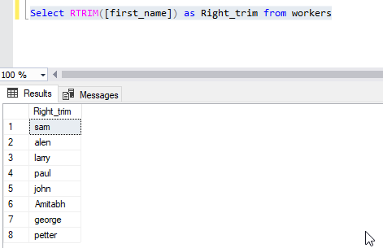

Q2. Write an SQL query the fetch the unique values of DEPARTMENT from Worker table and prints its length.

**Solution:**

Step-2. Use DISTINCT function to fetch unique values of DEPARTMENT column and LEN function for its length

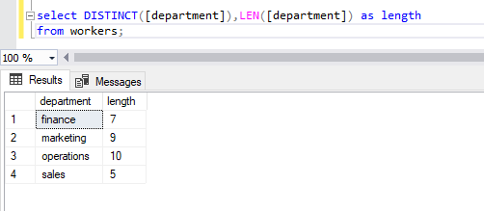

Q3. Write an SQL query to fetch nth max salaries from a table.

**Solution:**

Step-3. Use MAX function to fetch max salaries from a table.